**Birla Institute of Technology & Science, Pilani**

**Work-Integrated Learning Programmes Division**

**Mid Semester Examination**

Course No. : DSECL ZG557

No. of Pages = 2

*No. of Questions = 3*

Course Title : Artificial & Computational Intelligence

Nature of Exam : Open Book

Weightage : 30%

Duration : 1.5 Hours

Date of Exam : 22 / 11 / 2020, AN Time of Exam: 2:00 PM to 3:30 PM

**Answer all the questions**

**Question -1 [ 2+1+2+5 =10 M]**

(1-a) Consider that you are designing a CoViD screening agent for an airport to filter some doubtful passengers.

State the percepts, actions, goals and environment of that agent

**Percepts: Body Temperature, Answers for questionnaire**

**Actions: Filter and Recommend Quarantine**

**Goals: Effective filtering**

**Environment: Incoming passengers**

(1-b) What is the type of above agent.

**Simple reflex agent**

(1-c) Define the performance measure for the above agent.

**Let P be the count of symptomatic people among T the total people and D be the detected count.**

**Then P*Reward – (P-D)*Penalty**

**The constants Reward and Penalty can be constants of student’s choice.**

(1-d) Justify whether the environment for that agent is

1. Accessible or **inaccessible**.
2. Deterministic or **nondeterministic**
3. **Episodic** or non-episodic
4. Static or **dynamic**.
5. **Discrete** or continuous.

**Question -2 [3+3+4 =10 M]**

(2-a) Suppose hill climbing has a probability p=0.2 of getting successful in a particular run. What is the expected number of runs required for hill climbing with random restarts to be successful? (3)

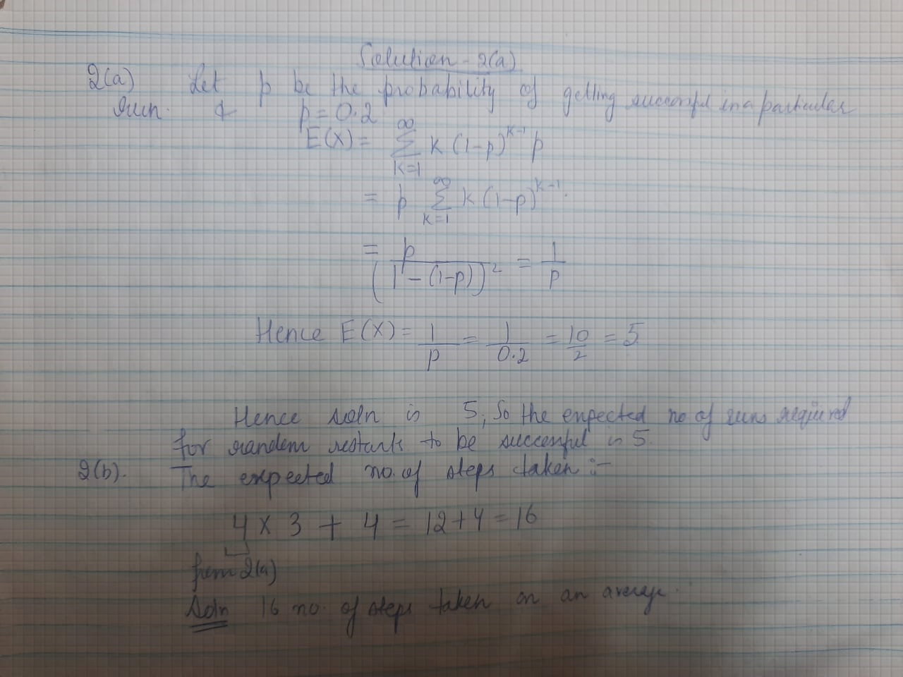

(2-b) Hill Climbing solves 14% of the problems within 4 steps on average. It gets stuck in local optima 86% of the time within 3 steps on average. Use the result calculated in (a) to compute the expected number of restarts and the expected number of steps taken. Show your calculations. (3)

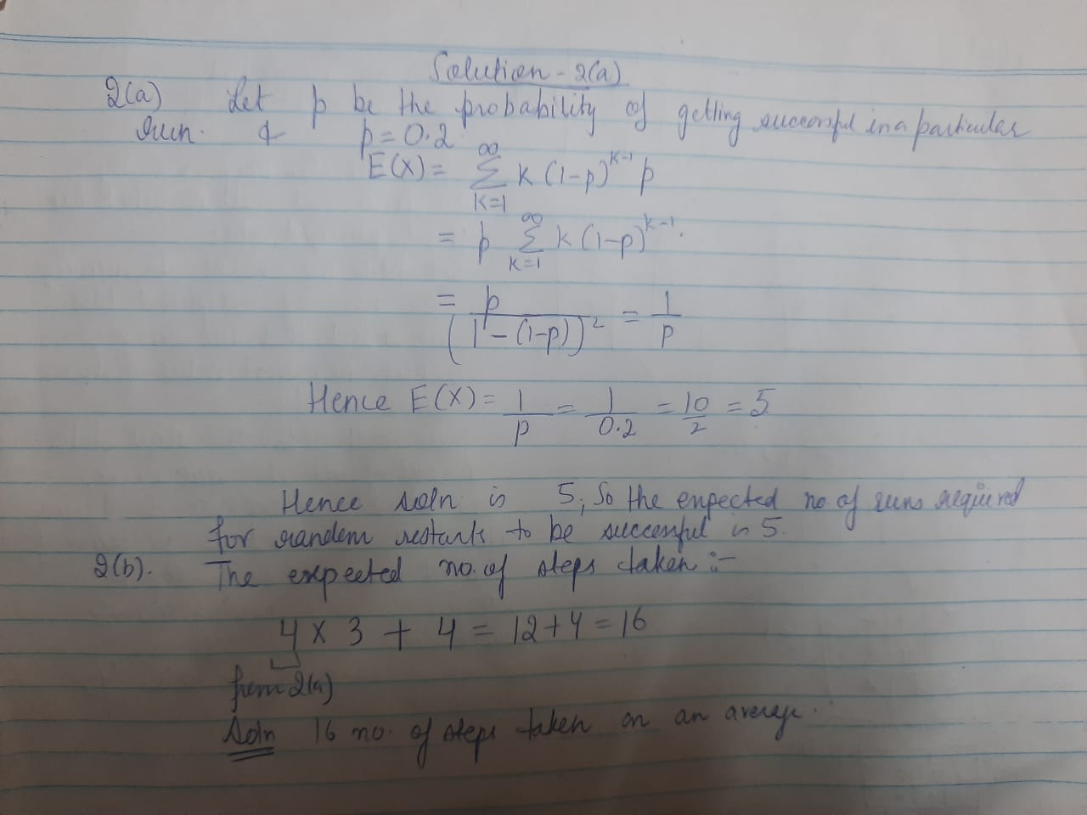

(2-c) Describe greedy Hill-Climbing search to go from state A to state B where h(s)=number of tiles misplaced in start state w.r.t B. Also state the number of steps taken. (4)

Start State: A Goal State: B

|  |  |  |
| --- | --- | --- |
| 3 | 1 | 2 |
| 4 | 5 | 8 |
| 6 | 7 |  |

|  |  |  |
| --- | --- | --- |
|  | 1 | 2 |
| 3 | 4 | 5 |
| 6 | 7 | 8 |

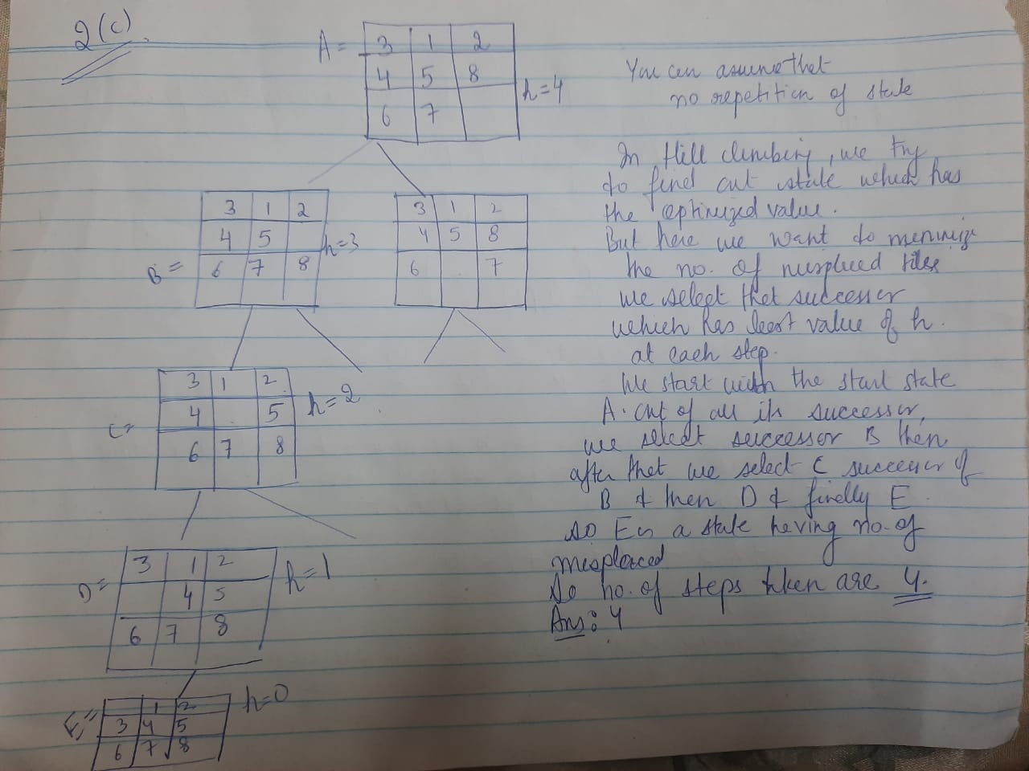

**Question -3 [ 5+5 =10 M]**

**3(a**) Consider a full binary (every internal node has a degree 2 and there are 2n leaves) of height n. Enumerate the nodes in the level at heigh (n-1) from 1 to 2n-1 (left to right) and let the goal state be the (2n-2+1)th node at that level. What is the absolute difference between the number of nodes explored by DFS and BFS algorithms starting at the root? Assume n>1 and left-to right exploration. Show your steps.

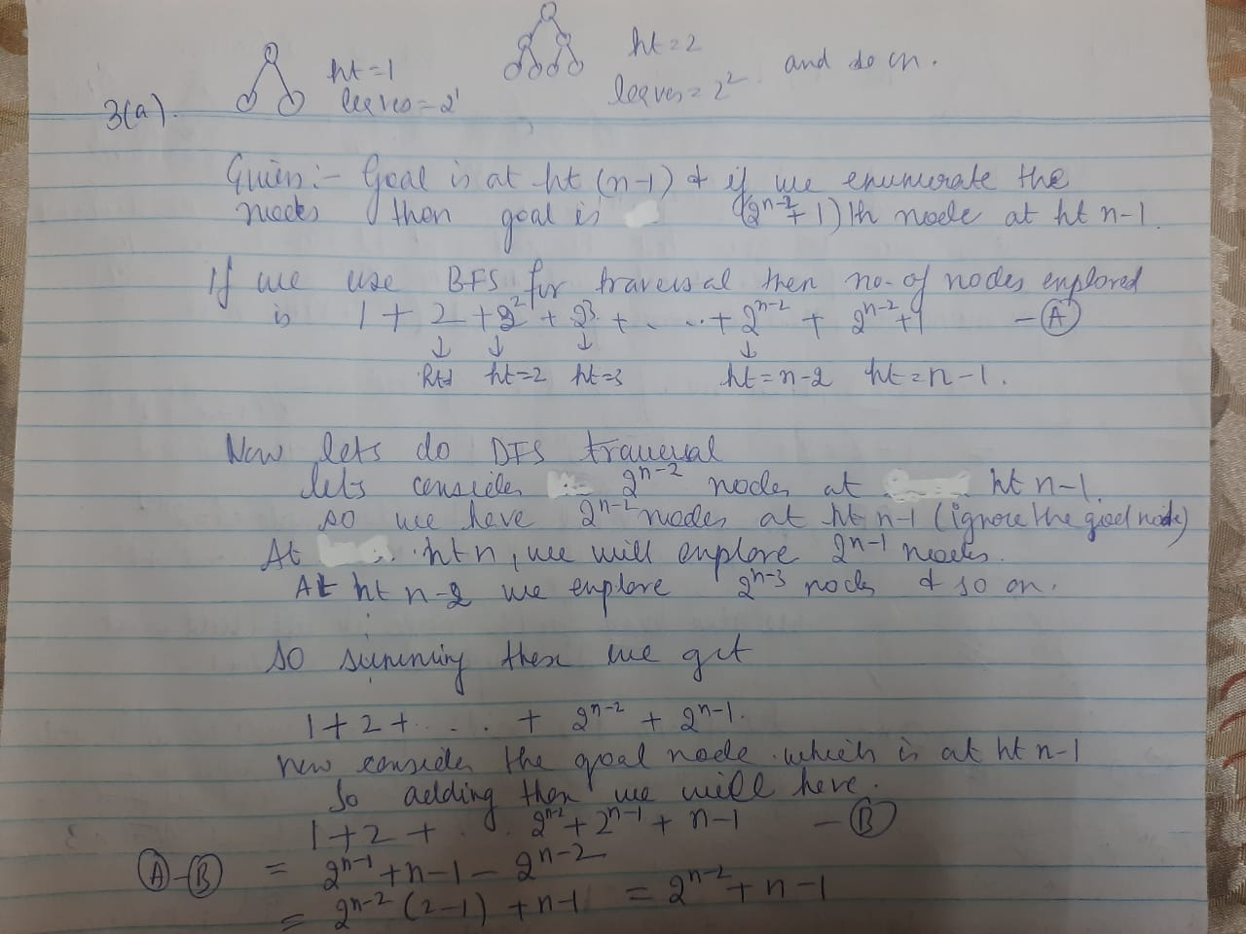

**3(b)** Consider the following graph in which we are searching from start state A to the goal state J. What are the number of nodes generated by iterative Deepening Search? Also show the sequence of the nodes explored. Assume that the nodes to be explored from right-to-left order and all edge costs are 1. Note: exploration of the goal state J should be added to the count.



